DeepL
An Overview by Samin Ahmed Rafid
What is DeepL
DeepL is an AI-powered translation and writing platform known for producing natural and human-like translations. Founded in Germany and launched publicly in 2017 by Jarek Kutylowski, it evolved from the Linguee dictionary/search engine project. It includes translation tools, writing assistance, voice translation, and APIs for developers and businesses.
DeepL became famous because its translations sounded more natural than many earlier machine translators. It focuses heavily on sentence context, tone, and fluent phrasing. It demonstrated that specialized AI systems can outperform broader systems in specific tasks. That is how DeepL became one of Europe’s major AI success stories and helped improve standards for machine translation worldwide.
How DeepL Works
DeepL uses Neural Machine Translation (NMT), deep learning, and large language models. Instead of translating word-by-word, it analyzes the meaning and context of entire sentences before generating translations.

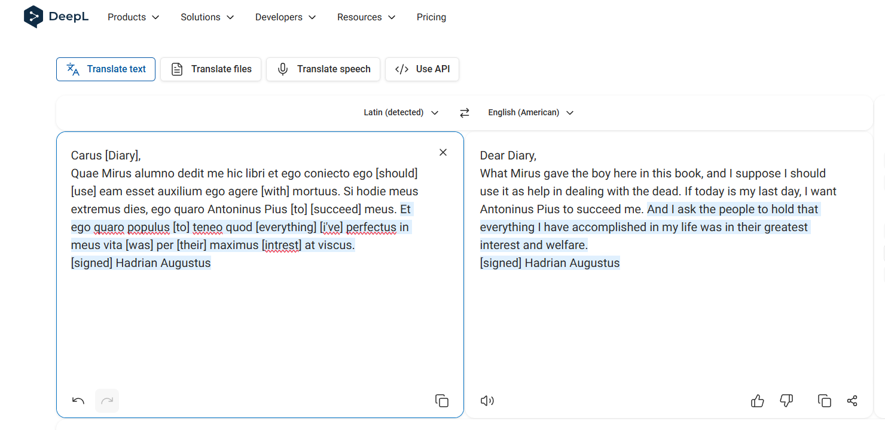
Main Products
1. DeepL Translator – Text and document translation.
2. DeepL Write – AI writing assistant for grammar and style improvements.
3. DeepL Voice – Real-time speech translation for meetings and conversations.
4. DeepL API – Integration tools for apps, websites, and business systems.

Key Features
• Document translation with formatting preservation.
• Custom glossaries for businesses.
• Tone and style adjustments.
• Privacy-focused enterprise options.

Pricing
DeepL offers free, professional, enterprise, and API-based plans. Paid subscriptions provide better privacy, larger uploads, and advanced business features.

DeepL vs Google Translate
DeepL is usually considered better for natural phrasing and professional writing, especially in European languages. Google Translate offers broader language coverage and ecosystem integration.

DeepL vs ChatGPT
DeepL excels at focused translation and terminology consistency, while ChatGPT is more flexible for explanations, creative rewriting, and conversational adaptation

Strengths
• Very natural translations.
• Strong enterprise features.
• Excellent document handling.
• Simple and clean interface.

Weaknesses
• Smaller language coverage than Google Translate.
• Translation inaccuracies can still occur.
• Human translators are still necessary for sensitive fields such as law and medicine.

Real-World Uses
People and businesses use DeepL for education, research, customer support, app localization, global teamwork, and multilingual communication.

The Future of DeepL
DeepL is expanding into voice AI, enterprise communication systems, writing assistants, and real-time multilingual collaboration tools.

